## Turning up the temperature: understanding the impact of charring between 215- 300°C on cereal grain morphology and stable carbon and nitrogen isotope values in rye, oat, wheat and barley

### Abstract

The stable isotope values of charred crops are now frequently analysed in archaeology. While previous research has highlighted how grain morphology and stable carbon and nitrogen isotope values change with grain charring temperature, such research has been limited to temperature ranges under 260°C and using predominately Mediterranean cereals and pulses. For the first time, this study provides experimental data on the impact of charring on two northern European cereals, rye and oat, both morphologically and isotopically. New experimental charring of rye, oat, wheat and barley extends the charring window to 300°C, providing an insight into the morphological changes to the grains as well as the difference between charred and uncharred isotopic values. This range of cereals and conditions opens up potential for stable isotopic investigation of medieval agricultural growing conditions and practices in Britain. The results indicate that isotopically, a 0.16‰ and a 0.32‰ offset should be applied to δ13C and δ15N values, respectively, of grains charred between 230 and 300°C. Morphological and internal structural changes, as well as external distortion, are key attributes which vary with charring temperature and duration. Guidelines are provided to enable assessment of whether archaeological grains of wheat, barley, rye and oat fall within the acceptable charring window for isotopic analysis.

### Introduction

Use of stable isotope values from archaeological crops provides an increasingly valuable tool, in conjunction with crop weed analysis, for the understanding of past agricultural systems. The interpretation of isotopic data from plant remains preserved at archaeological sites by charring requires knowledge of the effect of the heating regime on their isotopic composition. The charring process, partially involving the Maillard reaction, which converts sugars and amino acids to more stable compounds, also influences the isotopic composition of the grains (Nitsch et al. 2015). Two papers published in 2015 investigated the effect of a range of heating regimes on crop seed morphology and isotopic values and have shown that heating grains at 220-240°C produces grains which resemble well-preserved archaeobotanical material (Charles et al. 2015). Furthermore, research indicates that grains charred within a temperature window of 215-260°C have altered isotopic ratios and consequently, if isotopic ratios of charred grain are compared to uncharred grains, or if the isotopic results of charred grains are used within palaeodietary reconstructions, an offset is needed. Research has addressed this issue by producing modelled offsets to “correct” the charred isotopic value back to an “uncharred” value (Aguilera et al. 2008, Fraser et al. 2013, Nitsch et al. 2015, Styring et al. 2019).

Previous research by Nitsch et al. (2015) has investigated the effect of charring on the stable carbon and nitrogen isotope values of a suite of crop taxa typically found at Mediterranean/ South West Asian archaeological sites (see Table 1): bread wheat, emmer, einkorn, barley, lentil and pea. However, the applicability of their offset to taxa outside this crop suite requires testing. This paper builds on such research by investigating the effect of heating regimes on the morphology and stable carbon and nitrogen isotope values of rye, oat, bread wheat and barley, the four species common to Northern European sites, and in particular, Medieval contexts (Hamerow et al. 2020). Bread wheat and barley have been previously studied (see. Nitsch et al 2015); however, to understand the effect of higher temperatures on grain morphology and isotopic values, this paper extends their heating temperature range to 300°C.

Table 1. Various research conducted on the effect of charring, including the range of species examined, the temperatures and durations used.

|  |  |  |  |  |  |  |  |
| --- | --- | --- | --- | --- | --- | --- | --- |
| Study | Species | Temperatures  (°C) | Time (hrs) | Effect | | Isotopic offset | |
| δ15N | δ13C | δ15N | δ13C |
| Poole et al. 2002 | Pea | 130 to 700 | 1 |  | Differing by -0.5 to +2‰ from uncharred |  |  |
| 190, 250, 340 | 2 |
| Nitsch et al. 2015 | Bread wheat, barley, einkorn, emmer, pea, lentil | 215, 230, 245, 260 | 4, 8, 24 | Increase by 0.04‰ for every 4 hrs and 0.12‰ for every 15°C | Increase by 0.016‰ for every 4 hrs | 0.31 | 0.11 |
| Hartman et al. 2020 | Lentil | 100 to 400 | 2 | Constant till 200°C,  + 0.8‰ at 300°C, +2.2‰ at 400°C | Significant change above 400°C |  |  |
| Fraser et al. 2013 | Barley, bread wheat, einkorn, emmer, broomcorn millet, pea, lentil, broad bean | 230 | 2,4,8,24 | gradual increase resulting in a +0.8‰ difference at 24hrs |  | 1 |  |
| Aguilera et al. 2008 | Wheat, barley | 250 |  |  |  | 0.68 |  |
| Styring et al. 2019 | Pearl millet | 215, 230, 245, 260 | 4, 8, 24 | Maximum difference of 0.34 |  | 0.34 |  |
| Hart and Feranec 2020 | Maize | 180, 220, 260 | 2 | Increase with temperature to 0.96±0.2 at 260°C | Increase with temperature, +0.56 ±0.38 by 260°C | 0.54 |  |
| 180, 220 | 24 |

This paper reports on the impact that increasing the charring range to 300°C has on the morphology of the wheat, barley, rye and oat and the isotopic consequence of a higher charring temperature. The 215-260°C charring window advocated by Nitsch et al. (2015) as the optimal range from which to select isotopic samples is based on temperatures which experimentally produce well preserved and identifiable grains of their studied species; some species are difficult to separate visually when charred above 260°C (Charles et al. 2015).The relevance of this cut-off will be explored for the expanded range of taxa as there may be no isotopic reason for discounting grains charred above this threshold.

This study aimed to investigate three questions. Firstly, what are the morphological indicators of charring for bread wheat, hulled barley, rye and oat, at a range of temperatures and durations (215-300°C, 4-24 hours) and how can these be used to help select samples suitable for isotopic analysis? Secondly, what is the effect of charring on the δ13C and δ15N values of these crops under these conditions? And thirdly, can the changes in isotopic ratios be compensated for by using charring offsets for the four species at different temperature range combinations?

### Methods

#### Material and Sampling

This experiment followed the methodology set out by Nitsch et al. (2015), allowing comparability and the use of their bread wheat and hulled barley samples charred at 215°C, 230°C, 245°C and 260°C for 4, 8 and 24 hours.

Rye and oat grains were obtained from organic farms. The rye grains were obtained from Whitehall Farm, Peterborough, UK and the oat grains from Tamarisk Farm, Dorset, UK. The hulled barley grains came from the same batch of material that Nitsch et al. (2015) used in their experiment, a single field in the Sault region of Provence, France, harvested in 2013. The bread wheat came from plot 18 of the Bad Lauchstädt long term static fertilization experiment in Germany, harvested 2004. A third new species, spelt, was also charred but not included in the statistical calculations below as these were tailored for northern European medieval assemblages; full isotopic details for spelt are included in Stroud et al (X).

A total of 800 grains each of rye and oat were required to cover the 16 different combinations of temperature and time (15 charred batches + 1 uncharred). 50 grains per taxon were selected for each of the different conditions, providing three replicates of 10 grains per condition and a spare 20 grains for photography and morphological assessment. The batches were weighed before and after charring to understand mass loss for the different charring conditions (see Stroud et al X for data). For the barley and wheat batches, only 200 grains were required, as they were only charred at 300°C for 4hr, 8hrs or 24hrs, as well as a batch of 50 grains used as a control uncharred sample.

#### Charring

Oat and rye were charred at five different temperatures for 4, 8 or 24 hours, and an additional batch of bread wheat and hulled barley from the Nitsch et al. (2015) experiment was charred at 300°C for 4, 8 or 24 hours. The grains to be charred were wrapped in foil envelopes and buried in sand for the allotted duration (see Fraser et al. 2013, Nitsch et al. 2015). A Gallenkamp Plus II oven was used for charring, with the oven preheated to the required temperature before the samples were placed inside. Thermocouples were buried inside beakers of sand at three points in the oven, while a fourth thermocouple monitored the oven temperature outside the sand. A datalogger recorded the temperature over the duration of charring and it indicated that average temperature variability once the oven reached the set temperature was less than 3%. The grains were removed from the oven at the end of the heating period and left to cool to room temperature within their beakers of sand.

#### Sectioning and Photography

A subset of grains not used for isotopic analysis was examined under a microscope to understand the impact of charring on the external and internal morphology of the grains at each temperature and duration combination. The grains were sectioned in half, at right angles to the ventral groove, allowing for the internal structure to be examined. Photographs were taken of the internal and external morphology of the grains using a Lecia stereo microscope with a Lumenera infinity 3-6 UR digital camera.

#### Isotopic analysis

Three batches containing 10 grains each, for each temperature/duration combination, were analysed isotopically at the University of Oxford’s Research Laboratory for Archaeology and the History of Art. Batches of ten grains of the charred material were homogenised using an agate mortar and pestle. The uncharred materials, due to their harder, less brittle nature, were homogenised using a Spex 2760 Freezer/Mill. The resultant homogenised powders were weighed into tins and analysed on a Sercon EA-GSL mass spectrometer. An internal alanine was used to obtain raw and drift-corrected delta values, while carbon and nitrogen were measured in separate runs.

A two-point calibration was conducted using IAEA- N1 and IAEA-N2 for nitrogen, and IAEA-C7 and IAEA-C6 for carbon for the majority of samples, with a small number calibrated using the internal standards of SEAL and EMA-P2. Check standards of Alanine, and EMA-P2 or Leucine, as well as the duplication of every tenth sample, were used in conjunction with the calibration standards to understand accuracy and precision (as per Szpak et al. 2017) (see Stroud et al X for analytical details). The accuracy (u(bias)) of the carbon runs was ±0.16‰, while the precision (u(Rw)) was ±0.08‰. Overall total analytical uncertainty for δ13C values was ±0.18‰. For nitrogen the accuracy was ±0.52‰, while precision is ±0.27 ‰ and overall analytical uncertainty for δ15N values is ±0.58‰.

Previous isotopic analysis by Nitsch et al. (2015) of bread wheat and hulled barley was used in the statistical calculations below. This study used slightly different calibration standards; USGS40 was used instead of IAEA-N2. Their measurement uncertainly was calculated using Kragten approximation methods (Kragten 1994) and no samples were duplicated. To compare the two sets of data, the Kragten approximation method was also applied to the new isotopic samples’ results. The average measurement uncertainty for all the isotopic values used below, new and old (as per Kragten 1994), was 0.08‰ for δ13C values and 0.31‰ for δ15N values.

All statistical analysis and graphing were conducted using R-Studio and R version 4.1. For ease of comparison, graphs have been designed to replicate those published in Nitsch et al. (2015).

### Results

#### Physical changes

The experimental results show that the colour, distortion and internal structure of the grain closely reflects the heating regime. The morphological changes (distortion) seen in the grains for each heating regime cannot be explored fully in this paper. Instead, a summary of the major changes in the three main categories for each species is shown in Table 2, which classifies such changes into scores ranging from 0 (unchanged/undistorted) to 4 (major distortion/ significant internal changes). These changes are summarised below, while full photographs are available in Stroud et al (X).

The experimental charring showed that the colour of a grain section is consistently black at temperatures of 230°C and higher, even after the shortest time period tested (4 hours). The results resemble those for einkorn and emmer wheat (Charles et al. 2015, 9), suggesting that the grain is sufficiently altered to allow archaeological preservation by charring. At 215°C grains of all taxa are fully blackened after 8 hours except for rye where the change only occurs after 24 hours (see Table 2 for details).

The second category, distortion, refers to both internal and external evidence of change to the size and shape of the grain. Cross sections of all the taxa revealed the tendency of the grains to become rounder at higher temperatures. This was also evident in changes to the morphology of the grain’s ventral groove. Changes to the ventral groove are species dependant due to differences in ventral groove morphology. Typically, the ventral groove becomes shallower as the grain swells and in most cases the ventral groove acts like an expansion pleat, allowing the grain to swell without splitting. All the grains in the study were substantially distorted at 300°C. However, unlike colour, distortion is significantly variable across the different taxa, presumably due to their different chemical composition, which cause the taxa to react differently at varying temperature levels/ durations. Significant distortion (score of 4) was recorded in barley at 230°C at 24 hours, oat at 260°C for 8 hours, bread wheat at 300°C for 4 hours and rye for 24 hours in at 260°C.

The final category relates to internal structure and covers two main attributes of the grain’s cross-section: cell/matrix arrangement, and the appearance of cracks and voids. Cracks occurred at lower temperatures, hypothesised as a consequence of rapid grain dehydration (Charles et al 2015:7), while voids occurred at a higher temperature and tended to be rounded in appearance and more commonly found in the centre of the matrix. Changes to the internal structure of grains occurs from 215°C onwards (Table 2). Again, there are differences between the four species similar to and associated with those observed in grain distortion. Barley grains show voids at the lowest temperature (245°C) followed by rye and oat (260°C) and lastly bread wheat (300°C) and barley tending to score higher at the lower temperatures than oat and rye.

Table 2. The charring matrix displaying scores for colour, distortion and internal structure of the four species, rye, wheat, barley and oat, at the three durations and five temperature combinations. A brief summary of scoring criteria is shown below with full details in supplementary materials

|  |  |  |  |  |  |  |  |  |  |  |  |  |  |  |  |  |  |  |  |
| --- | --- | --- | --- | --- | --- | --- | --- | --- | --- | --- | --- | --- | --- | --- | --- | --- | --- | --- | --- |
|  | | | Colour | | | | | | Distortion | | | | | | Internal Structure | | | | |
| 215°C | 230°C | 245°C | 260°C | | 300°C | 215°C | 230°C | 245°C | 260°C | 300°C | | 215°C | 230°C | 245°C | 260°C | 300°C |
| Rye | 4hrs | | 2 | 3 | 4 | 4 | | 4 | 1 | 1 | 2 | 2 | 3 | | 0 | 2 | 2 | 4 | 3 |
| 8hrs | | 3 | 4 | 4 | 4 | | 4 | 1 | 1 | 3 | 3 | 3 | | 1 | 2 | 2 | 3 | 3 |
| 24hrs | | 4 | 4 | 4 | 4 | | 4 | 3 | 3 | 3 | 4 | 4 | | 2 | 2 | 3 | 4 | 4 |
| Wheat | 4hrs | | 3 | 4 | 4 | 4 | | 4 | 1 | 2 | 3 | 3 | 4 | | 1 | 3 | 3 | 3 | 4 |
| 8hrs | | 4 | 4 | 4 | 4 | | 4 | 2 | 2 | 3 | 3 | 4 | | 2 | 3 | 3 | 3 | 4 |
| 24hrs | | 4 | 4 | 4 | 4 | | 4 | 2 | 2 | 3 | 3 | 4 | | 2 | 3 | 3 | 3 | 4 |
| Barley | 4hrs | | 3 | 4 | 4 | 4 | | 4 | 2 | 3 | 4 | 4 | 4 | | 1 | 2 | 4 | 4 | 4 |
| 8hrs | | 4 | 4 | 4 | 4 | | 4 | 2 | 3 | 4 | 4 | 4 | | 1 | 3 | 4 | 4 | 4 |
| 24hrs | | 4 | 4 | 4 | 4 | | 4 | 3 | 4 | 4 | 4 | 4 | | 1 | 3 | 4 | 4 | 4 |
| Oat | 4hrs | | 3 | 4 | 4 | 4 | | 4 | 2 | 2 | 2 | 3 | 4 | | 0 | 2 | 2 | 3 | 4 |
| 8hrs | | 4 | 4 | 4 | 4 | | 4 | 2 | 3 | 2 | 4 | 4 | | 1 | 2 | 2 | 3 | 3 |
| 24hrs | | 4 | 4 | 4 | 4 | | 4 | 2 | 3 | 3 | 4 | 4 | | 1 | 3 | 3 | 4 | 4 |
| Scoring criteria | | | | | | | | | | | | | | | | | | | |
| Score | | Colour | | | | | Distortion | | | | | | | Internal structure | | | | | |
| **0** | | uncharred | | | | | unchanged | | | | | | | unchanged | | | | | |
| **1** | | pale | | | | | slight | | | | | | | dense, no voids | | | | | |
| **2** | | light brown | | | | | slight to moderate | | | | | | | dense, no voids (but possible expansion cracks) | | | | | |
| **3** | | dark brown | | | | | moderate to major | | | | | | | less dense, no voids but possible expansion cracks | | | | | |
| **4** | | black | | | | | major | | | | | | | less dense, voids | | | | | |

Overall morphology, in particular grain colour and distortion, suggests that grains charred under 215°C will not commonly be recovered at archaeological sites. The incomplete blackening of the grain at 215°C is seen in all species and suggests that at lower temperatures these grains would only be partially charred, and the starches and proteins in the grains may not have been converted to microbially unavailable Maillard reaction products.

#### Carbon isotope results

The four taxa have δ13C values ranging from -27.9‰ to -24.9‰ for the uncharred material, while the charred material is slightly more variable with a range of -28.3‰ to -24.6‰. Plotting the charred grains’ δ13C values against the average of the uncharred replicates shows this variability especially in the rye and oat (Figure 1). Bread wheat has an upwards trend in the δ13C value with temperature, as noted by Nitsch et al. (2015); the added 300°C batches are consistent with this trend. Oat and rye δ13C values are significantly more variable than the δ13C values of bread wheat, in some cases deviating from the mean uncharred value by 1‰.

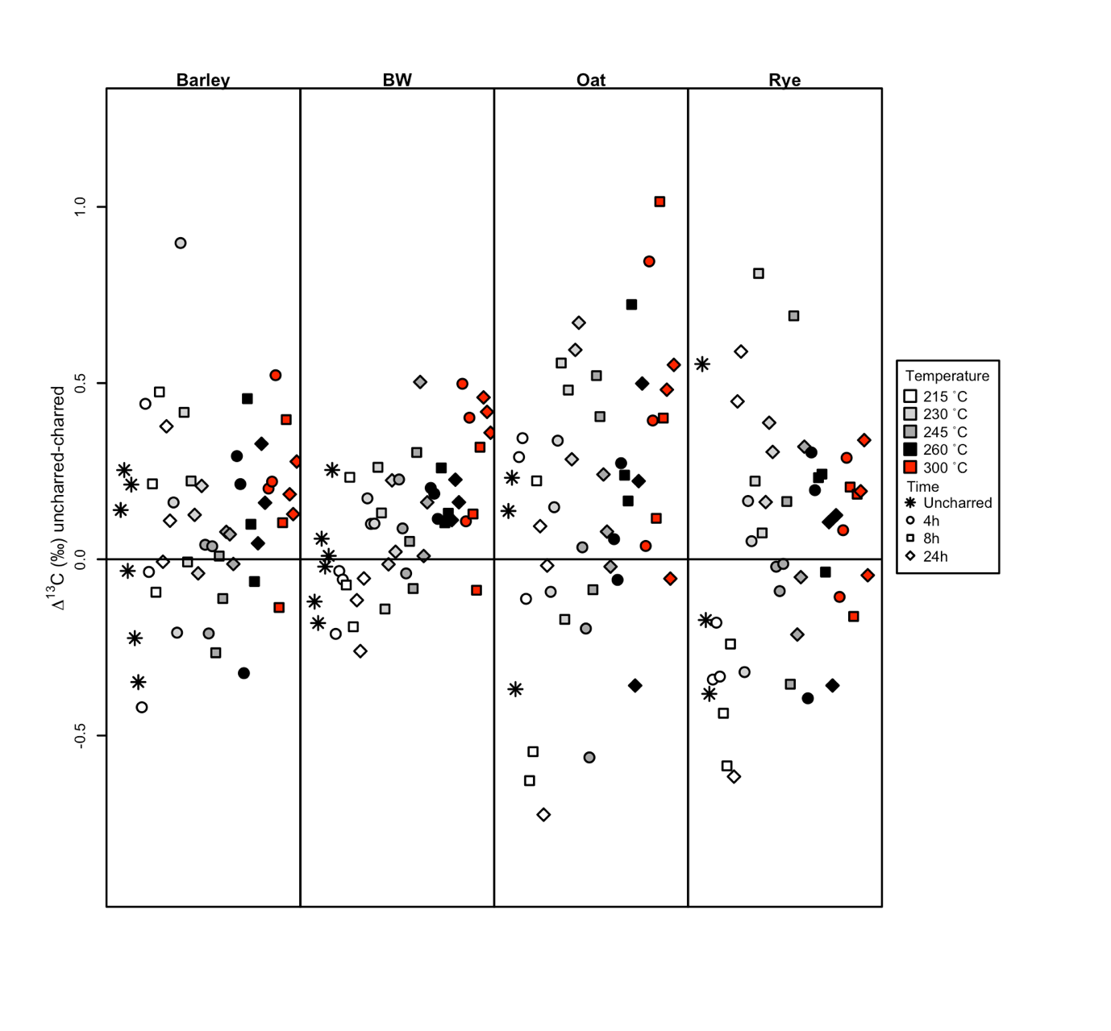

Figure 1. The δ13C values of barley, bread wheat (BW), oat and rye for the different times and temperature combinations compared to the mean δ13C value of uncharred replicates

The charred material was examined to ascertain the impact of heating regime on δ13C values. A multiple linear regression with coefficients for temperature, time and species was used, following Nitsch et al. (2015), and Table 3 details the results using the differing combinations of temperature ranges. For δ13C values of the four species, temperature is only significant if the 215°C batches are included in the analysis – regardless of whether the highest temperature is 260°C or 300°C. Time is never significant in any of the permutations (Table 3). The effect that temperature has on the δ13C value is limited, with the greatest impact in the 215-260°C and 215-300°C analysis with a change of 0.05‰ every 15°C, resulting in a 0.14‰ difference between 215°C and 260°C, and a difference of 0.26‰ between 215°C and 300°C.

Table 3. The results of a multiple linear regression with coefficients of time and temperature on δ13C values, showing the p-value and the beta value rounded to 2 decimal places.

|  |  |  |  |  |  |
| --- | --- | --- | --- | --- | --- |
|  | | 215-260°C | 215-300°C | 230-260°C | 230-300°C |
| Temperature | p-value | 0.04 | <0.01 | 0.27 | 0.06 |
| Beta | 0.01 | 0.01 | -0.01 | 0.01 |
| Time | p-value | 0.28 | 0.3 | 0.33 | 0.36 |
| Beta | 0.01 | 0.01 | 0.01 | 0.01 |

#### Nitrogen isotope results

The four taxa have δ15N values ranging from 0.17 to 4.1 ‰ for the uncharred material while the charred material is more variable (-0.1 to 6.2‰). Rye is the most variable of the four taxa, with the δ15N values of its 215°C material particularly so. Wheat’s δ15N values are variable at lower charring temperature batches, compared to the 260°C and 300°C samples. The variability is higher for δ15N values compared to δ13C values, something also noted by Nitsch et al. (2015).

There are notable trends detected when comparing the charred samples to the averaged uncharred value (Figure 2). Rye’s 215°C 4- and 8-hour samples have a mean similar to that of the uncharred material, while two of the subsequent 215°C 24-hour samples have some of the highest deviation from the uncharred mean. From 230°C onwards δ15N values decrease as temperature increases till the 300°C samples, which have similar values to the uncharred material. Oat samples show an initial increase in δ15N value at 215°C, the largest difference from the uncharred mean, and then a subsequent downwards trend in δ15N values in the following temperature batches. Barley and wheat δ15N value variabilities differ, being less variable than rye and oat. There tends to be a trend of increasing δ15N values as temperature increases, resulting in the higher temperatures having the largest difference from the uncharred material, corroborating a similar observation by Nitsch et al. (2015).

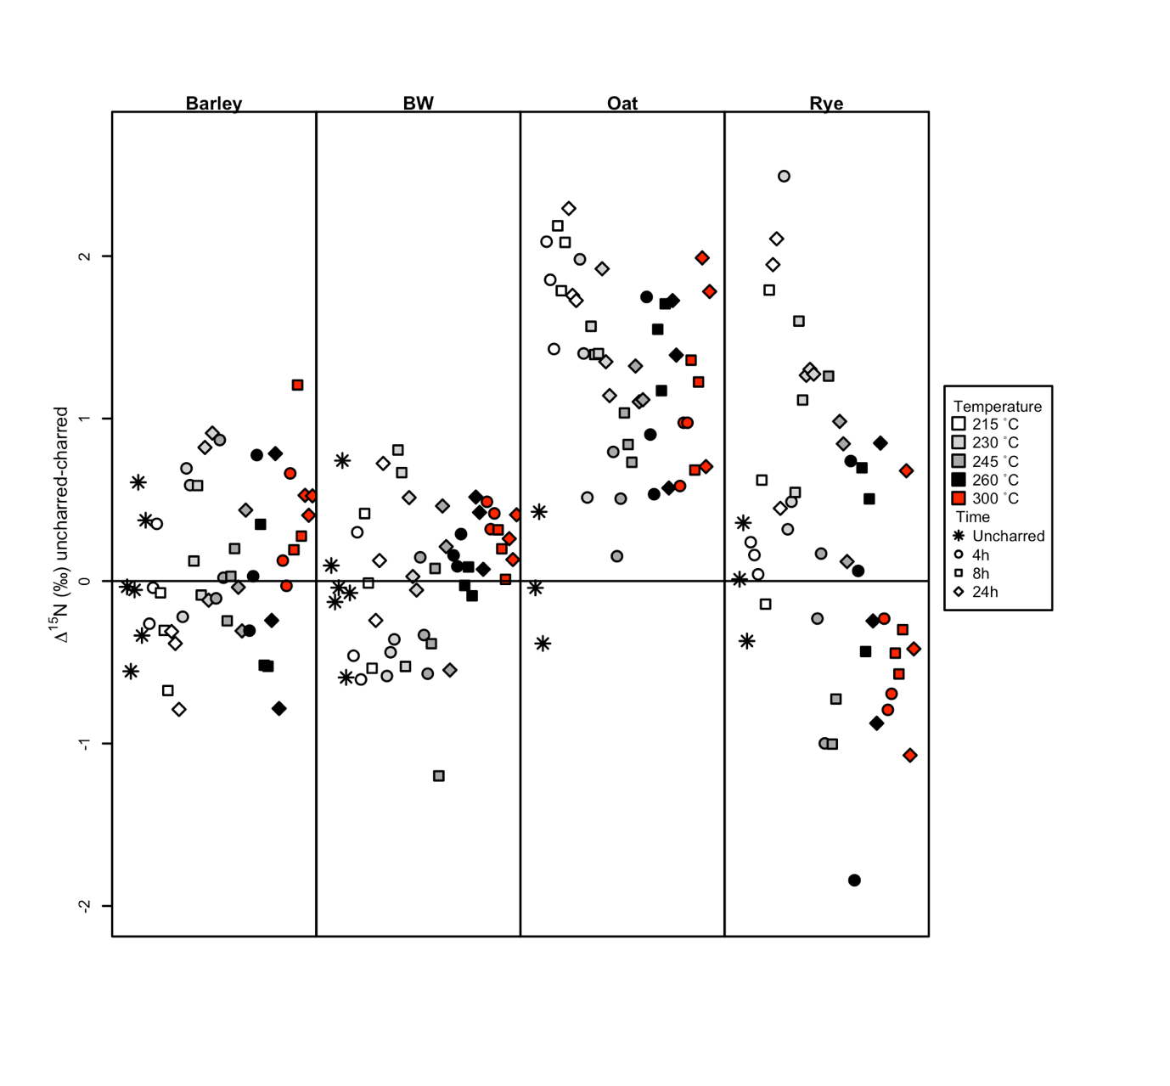

Figure 2. The δ15N values of barley, bread wheat (BW), oat and rye for the different times and temperature compared to the mean δ15N value of uncharred replicates

Statistical analysis of the isotopic values of charred material was conducted using a multiple linear regression with coefficients for temperature, time and species; the same method as used for the carbon isotope analysis. When the 215°C batches are included as the lowest temperature, both time and temperature are significant in the regression model – regardless of whether the highest temperature is 260°C or 300°C (Table 4). The results suggest that there is a 0.05 to 0.14‰ decrease in δ15N value for every 15°C when the 215°C batches are included. This is a negative relationship with the highest δ15N value at 215°C; the value decreases by 0.41‰ by 260°C (0.31‰ between 215°C and 300°C using the 215-300°C model). When the temperature range is restricted to just 230-260°C there is a significant difference between the batches for temperature, and a moderately significant difference for time. Analyses of the 230°C to 300°C range finds that just time is significant at the 0.05 level.

Table 4. The results of a multiple linear regression with coefficients for time and temperature on the δ15N values showing the p-value and the beta value rounded to 2 decimal places.

|  |  |  |  |  |  |
| --- | --- | --- | --- | --- | --- |
|  | | 215-260°C | 215-300°C | 230-260°C | 230-300°C |
| Temperature | p-value | <0.01 | 0.02 | <0.01 | 0.1 |
| Beta | -0.01 | -0.01 | -0.02 | -0.01 |
| Time | p-value | 0.02 | <0.01 | 0.05 | 0.03 |
| Beta | 0.01 | 0.01 | 0.01 | 0.01 |

#### Difference between charred and uncharred: calculating a charring offset

A charring offset was calculated using the same method as Nitsch et al. (2015). Nitsch et al. (2015) compared the isotopic ratios of all the charred samples to uncharred samples, advocating this method due to the difficulty in distinguishing between the different temperatures and times of archaeological seeds. The charring morphology experiment conducted for this paper highlights the difficulty in distinguishing between grains charred between 230°C and 260°C, while duration of charring appears very difficult to distinguish morphologically. This is compounded by the fact that archaeological specimens may have undergone a range of different temperatures for different durations during charring.

### Carbon offset

The charred materials’ δ13C values were compared to the uncharred material using two different linear models as per Nitsch et al. (2015). The first linear model examined the relationship between δ13C values and species; the second included an extra coefficient for charring (i.e., charred vs non-charred values with no regard for charring time or temperature). Table 5 summarises the results for the different temperature batches used.

Table 5. The results from the first (LM1) and second (LM2) linear models based on the δ13C values, showing the R2 value, p-value of the model, p-value of the charred-fresh coefficient, the Beta value and the confidence intervals, for the four different temperature ranges rounded to 2 decimal places

|  |  |  |  |  |  |  |  |  |
| --- | --- | --- | --- | --- | --- | --- | --- | --- |
|  | 215-300°C | | 215-260°C | | 230-300°C | | 230-260°C | |
|  | LM1 | LM2 | LM1 | LM2 | LM1 | LM2 | LM1 | LM2 |
| Adjusted R2 | 0.87 | 0.87 | 0.87 | 0.87 | 0.89 | 0.89 | 0.89 | 0.89 |
| Model P value | <0.01 | <0.01 | <0.01 | <0.01 | <0.01 | <0.01 | <0.01 | <0.01 |
| Charred-fresh P value |  | 0.11 |  | 0.26 |  | 0.02* |  | 0.06 |
| Beta |  | -0.12 |  | -0.08 |  | -0.16 |  | -0.13 |
| CI 2.5% |  | -0.26 |  | -0.23 |  | -0.29 |  | -0.3 |
| CI 97.5% |  | 0.03 |  | 0.06 |  | -0.03 |  | 0.01 |

The first model (LM1), using all temperatures (215-300°C and the uncharred batches) for δ13C values produces a good fit (R2= 0.87) with all species’ coefficients significant. The addition of the charring coefficient to the model (LM2) only slightly increases the fit of the model (see table 5) and the p-value for charred-fresh is not significant. Table 5 shows the results of the second linear model when using different temperature range combinations. The 215-260°C range results suggests that there is no need for a charring offset as the difference between the charred and uncharred values are not significant. This does not change if the charring range is increased to 215-300°C as detailed above. When the 215°C batches are removed, there is a significant difference between the charred and uncharred material (p=0.02). This is because the δ13C values of the 215°C batches have very similar δ13C values to the uncharred batches. A 0.16‰ offset is recommended if the temperature range is restricted to 230-300°C. Restricting the temperature range to 230-260°C results in p-value between charred and uncharred of 0.06, a similar result to Nitsch et al. (2015) model’s p-value of 0.057 which they described as “moderately significant”. The offset of this paper’s model for a 230-260°C temperature range is 0.13‰, very similar to Nitsch et al. (2015), who proposed an offset of 0.11‰ for the temperature range of 215-260°C. However, the confidence intervals for the 230-260°C model do cross zero indicating that there is a possibility that this offset could also be zero. The charring offset for the four species within this study, wheat, barley, rye and oat differs only slightly from Nitsch et al. (2015) and the need for an offset is dependent on the range of charring temperatures chosen for the model.

The similarity of the δ13C values of charred grains to the uncharred values (see figure 1) at 215°C is evident in all four species. As reported above some of the grains, when charred at 215°C for some time durations (i.e., 4 hours and 8 hours), are still brown internally, raising the question as to whether grains charred at this temperature would survive within the archaeological record. Chemical research into whether grains at the lower temperatures have undergone the necessary chemical changes for survival is still required. If the 215°C batches are removed, the results suggest that inclusion of grains charred between 230-300°C would need an offset of 0.16‰ to be subtracted from the δ13C values of charred material in order to convert the values back to something comparable with uncharred grains.

### Nitrogen offset

The first linear model constructed with the δ15N data from all batches (215-300°C) (LM1) shows a good fit of the model with the data (R2= 0.84), with all species’ coefficients significant (Table 6). The addition of the charring coefficient (charred-fresh, LM2) only slightly increases the fit of the model (R2 =0.84); however, the charring coefficient is significant (p=0.04). For the four different temperature permutations the charred-fresh coefficients are significant within the models, indicating that a charring offset is required, regardless of the inclusion of the 300°C samples. When all temperature batches are included (215-300°C), the offset is 0.33‰ with a 95% CI between -0.62 to -0.02‰ (see Table 6).

Table 6. The results from the first (LM1) and second (LM2) linear models based on the δ15N values, showing the R2 value, p-value of the model, p-value of the charred-fresh coefficient, the Beta value and the confidence intervals, for the four different temperature ranges rounded to 2 decimal places

|  |  |  |  |  |  |  |  |  |
| --- | --- | --- | --- | --- | --- | --- | --- | --- |
|  | 215-300°C | | 215-260°C | | 230-300°C | | 230-260°C | |
|  | LM1 | LM2 | LM1 | LM2 | LM1 | LM2 | LM1 | LM2 |
| R2 (adjusted) | 0.84 | 0.84 | 0.85 | 0.85 | 0.83 | 0.83 | 0.83 | 0.84 |
| P-model | <0.01 | <0.01 | <0.01 | <0.01 | <0.01 | <0.01 | <0.01 | <0.01 |
| Charred-fresh P value |  | 0.04 |  | 0.04 |  | 0.04 |  | 0.05 |
| Beta |  | -0.33 |  | -0.33 |  | -0.32 |  | -0.31 |
| CI 2.5% |  | -0.64 |  | -0.64 |  | -0.62 |  | -0.62 |
| CI 97.5% |  | -0.02 |  | -0.01 |  | -0.02 |  | 0.01 |

There is always a significant difference between the charred and uncharred groups’ δ15N values if the 300°C temperature batches are included in the models, but without their inclusions p-values of the models sit around 0.05 (Table 6). The offset for the four temperature combinations differ only slightly to that recommended by Nitsch et al. (2015); Nitsch et al. (2015) proposed a δ 15N value charring offset of 0.31‰, while this study’s offsets range from 0.31 to 0.33‰. Unlike the carbon results, the inclusion of the 215°C batches does not significantly change the results. The 215°C samples from some of the taxa have δ15N values which differ greatly from the uncharred material, while the 300°C samples tend to have δ15N values similar to the uncharred material (see Figure 2). The different temperature combinations indicate that the charring window for these four species (bread wheat, barley rye and oat) can range from 215-300°C with limited impact on the overall δ15N charring offset. However, the analysis of charred material only does indicate that charring temperature impacts δ15N values with the model indicating a -0.31‰ difference between specimens charred at 215°C and those charred at 300°C. This is due to the large difference in the δ15N value of the 215°C batches of rye and oat, compared to the uncharred material. As explained above for the δ13C value offset, the inclusion of the 215°C batches could be problematic since there is uncertainty as to whether they have completed the chemical processes necessary for resistance to microbial decay. The differences noted with the rye and oat isotopic values highlight the need to conduct charring experiments of species potentially chemically different to other crop species which have been charred experimentally.

#### Variability and issues of comparability

Combining the Nitsch et al. (2015) isotopic values with the new values was carried out to reduce comparability issues. The barley and wheat grains used in this study are from the same field as those examined in the Nitsch et al. (2015) study; the barley the same material as used by Nitsch et al (2015) and the wheat also from the same field as Nitsch et al. (2015) but a from different year. To confirm there was no significant difference between the old and new grains, batches of uncharred barley and wheat were isotopically analysed and their values compared to those of the uncharred grain from the Nitsch et al. (2015) study. There is no statistically significant difference between the uncharred Nitsch et al. (2015) samples and the uncharred samples from this study (Welch two sample t-test, barley δ13C p-value = 0.3, δ15N p-value = 0.3, Wheat δ13C p-value = 0.2, δ15N p-value =0.9; see Stroud et al (X) for more detail).

There is a high amount of variability in the rye and oat batches compared to the bread wheat and to a lesser extent the barley. The higher variability seen in the rye and oat isotopic values is most likely due to the grains used in the experiment: the material was sourced from modern farms, the grains coming from a larger cultivated area than the bread wheat which was grown under experimental field conditions in a small plot. The oat came from a single field of ~ 5 ha, while the rye was also from a single field although its size is unknown. The bread wheat and barley, cultivated or collected from experiments, had some degree of uniform topography and soil conditions across the small plot/collection areas. Oat and rye grain, however, would have higher isotopic variability due to the wider range of cultivation conditions within large fields affecting δ15N and δ13C values.

Nitsch et al (2015) attempted to calculate the likely range of δ13C and δ15N values of samples from a single growing condition. They used the residual standard error (SE) of a multiple regression model which accounted for the effect of time and temperature (y = temp(x) + time(x), where y = δ13C or δ15N). Their calculations showed that 0.25‰ for δ13C and 0.75‰ for δ15N could provide a rough estimate of the expected population standard error of a given growing condition. Extrapolating from that (1.96 x SE) they calculated that a 95% CI of ±0.5 for δ13C and ± ~1‰ for δ15N would account for the variability within a single growing condition (Nitsch et al 2015).

The standard error of the species examined in this paper are within a similar range to those of Nitsch et al.’s (2015) (Table 7). Rye has the most variable isotopic values as noted above, and its standard error is high for δ15N but still below 1‰: similar to the high δ15N standard error that pea produced in the Nitsch et al. study. The variability of rye as mentioned above is mostly a consequence of the large area from which from the material derived (a large modern field).

The ±~0.5 ‰ and ±~1.0‰ 95% CI for δ13C and δ15N values, respectively, suggested by Nitsch et al. (2015), would still account for variability within a single growing condition when using bulk samples of ten grains for the species examined within this study. Studies using bulk samples of multiple grains of wheat, rye, oat or barley should interpret results with the understanding that the δ13C and δ15N values are only 95% likely to represent the true population mean using a confidence range of ±0.5‰ and ±1.0‰ respectively. Thus, as Nitsch et al (2015) pointed out, any difference in isotopic means of less than 0.5‰ (δ13C) and 1.0‰ (δ15N) should not be interpreted as significant.

Table 7. The residual standard error of a multiple regression model accounting for the effects of time and temperature (as per Nitsch et al 2015).

|  |  |  |
| --- | --- | --- |
| Taxon | δ13C (‰) | δ15N (‰) |
| Bread Wheat | 0.19 | 0.43 |
| Barley | 0.25 | 0.48 |
| Rye | 0.33 | 0.93 |
| Oat | 0.38 | 0.53 |

#### Discussion

This study has shown that while the effect of heat on crop grain morphology and δ15N and δ13C values follow broadly similar patterns to previous studies, there is some variation between taxa and that this needs to be accounted for in isotopic analysis. At 230°C after 4 hours, the grain of the four species become ‘charred’, i.e. pre-dominantly blackened across the cut section, level of grain distortion is low and identification to species level is relatively straightforward, and the internal cell structure has undergone a transformation (manifest as a more open/less dense appearance). Hulled barley is the most sensitive to heating temperature, with substantial morphological distortion occurring above 230°C. Increasing temperatures cause marked distortions in grain morphology and at 300°C, grain morphology is substantially altered, both internally and externally but identification to species is still possible and critically the effect on δ15N or δ13C values and the associated charring offsets is relatively limited. Consequently, such grain can be included in isotopic analysis.

At the other end of the heating range (215°C) grain is not undergoing the transformations necessary for archaeological preservation and there is considerable deviation in isotopic values from the uncharred samples, especially in the case of oat and rye. For these reasons we propose that grains charred at this low temperature should not be included in isotopic sampling. The uncertainty about the survival of grains charred below 230°C in the archaeological record, and the very different isotopic values of oat and rye grains charred at 215°C compared to the other temperatures, suggest that these grains should not be considered for isotopic analysis.

The results of this study, in conjunction with those of Nitsch et al. (2015), and other recent charring offset experiments on other species such as pearl millet (Styring et al. 2019), indicate that the application of a “charring offset” is necessary if either comparing the isotopic values of charred and uncharred archaeological material or using the isotopic value of charred grains in palaeodietary reconstruction. As seen in this study and others (Styring et al. 2019, Nitsch et al. 2015), the nitrogen offset appears to be around 0.3‰, with the four species in this study requiring a 0.32‰ offset. The use of a δ13C value offset appears to be dependent on the species and temperature range of the seeds analysed. For the four species examined here, bread wheat, rye, barley and oat, a δ13C value offset is only necessary if the lower temperature is removed (215°C) and the higher temperature of 300°C is included. This suggests that assemblages of extremely well-preserved material, charred below 260°C, may not require a δ13C value charring offset. However, if grains charred to 300°C are included, a charring offset, while small, is recommended.

### Selection of grains suitable for isotopic analysis

Through experimental charring, this paper has found that three categories of internal and external traits change depending on charring temperature and duration. The next step requires these traits to be translated into usable criteria to identify grains suitable for isotopic analysis. This paper advocates shifting the “charring window” set by Nitsch et al. (2015), from 215-260°C to 230-300°C for the four species studied. The dissection of the grain to understand any internal changes is key to assessing the suitability of the grains for isotopic analysis. The authors’ experience with grains from northern Europe has found that while many grains fulfilled the external morphological attributes of grain charred at an isotopically suitable temperature range (230°C to 300°C), internal changes indicated that they were more likely charred above 300°C. These grains were therefore not suitable for isotopic analysis because of uncertainty regarding their isotopic offset (Feedsax book ref/ADS).

A set of criteria was developed to help select archaeological grains of wheat, barley, rye and oat which fall within the 230°C to 300°C temperature range for the new isotopic offsets presented in this paper. Table 8 details the proposed criteria required to select suitable grains for isotopic analysis classifying them as either *good*, *borderline* or *bad.* It is advised that *bad* grains should not be isotopically analysed, while *borderline* grains can be. However, any interpretation of the resultant isotopic values should consider their possibly high charring temperature and different offset.

Table 8. The differences in colour, distortion and internal structure of archaeological wheat, barley, rye and oat grains which are good, borderline or badly suited for isotopic analysis () indicate the charring scores used in table 2.

|  |  |  |  |
| --- | --- | --- | --- |
|  | **Good (230 to +260°C)** | **Borderline (+260 - +300°C)** | **Bad (+300 °C)** |
| **Colour** | black (4), matt appearance | black (4), matt appearance | black (4), matt or glassy appearance |
| **Distortion** | slight to moderate (1-3) | moderate to major (2-4) | moderate to major (3-5+) |
| **Internal structure** | no to minimal voids, matrix dense (1-2) | moderate voids, matrix dense to moderately dense  (2-4) | major voids, less than half dense matrix surviving, matrix can look bubbly (5+) |

In addition to having a completely blackened grain matrix, the matrix of a grain suitable for isotopic analysis should be matte. Archaeological grains can, however, present with a matrix which appears glassy or vitrified (Figure X). We hypothesise that this glassiness is the result of high temperatures which have vitrified the grain’s matrix; such glassiness has not yet been replicated experimentally in either grains or wood and needs further investigation (see Courty et al. 2020 c.f. with McParland et al. 2010 for debate within anthracology as to whether high temperatures cause vitrification in charcoal). The lack of such glassiness in any experimental studies suggests that the conditions required to vitrify cells are not the same as those used thus far to char modern grains to determine isotopic offsets. Consequently, glassiness should currently be used as an attribute to rule out grains for isotopic analysis.

Grains should be selected that have limited distortion, i.e., changes to size and shape of grain (Table 8). However, it has been observed that some archaeological grains have limited external distortion but internally have large areas of glassy matrix or large voids (see Fig X). This highlights the need for grains to be dissected in half to ascertain their suitability for isotopic analysis, and furthermore, that all attributes in Table 8 must be used when selecting grains for analysis.

The charring experiment above (and others, such as Charles et al. 2015) shows that as charring temperature and duration increases, the matrix of a grain loses density, potentially a consequence of the cells losing internal material, and at higher temperatures cells can merge. The density of the matrix is especially important in separating archaeological grains suitable for isotopic analysis from those which are not: grains with limited amounts of dense matrix or large merged voids are hypothesised to be indicative of higher temperatures. The low-density matrix, coupled with large voids, are sound attributes for ruling out archaeological grains from isotopic analysis.

Species specific differences do occur; the experimental charring showed differences between wheat/barley compared with oat and rye. Barley tended to show higher amounts of distortion and internal changes at lower temperatures compared with rye, wheat and oat. The differences between species does highlight the importance of charring experiments to understand how different species change because of different charring conditions. Consequently, the above criteria, while they may be suitable for wheat, rye, barley and oat (and glume wheats such as spelt – see Stroud et al Xref??), other crop species such as pulses, millets or sorghums may present with different changes due to charring and warrant further investigation.

### Conclusion

This paper investigated the impact of charring, both morphologically and isotopically, on bread wheat, hulled barley, rye and oat. The isotopic effect of charring on wheat, barley, oat and rye at a range of temperatures and durations revealed differences, with δ13C values affected by temperature and δ15N values changing based on both temperature and duration. Furthermore, the construction of a model to predict a charring offset indicates that while a δ15N value offset is required regardless of the time/temperature combination used, a δ13C value offset is only significant when a 230-300°C temperature range is used. The differences in isotopic values of the 215°C experimental charred grains of oat and rye, coupled with the evidence that many of those grains are only partially coloured internally suggesting incomplete charring, lead us to advocate a charring window between 230°C and 300°C for the four species, excluding the lower temperatures grains (215°C). With a charring range of 230°C to 300°C, the isotopic offsets for wheat, barley, rye and oat are 0.32‰ (δ15N, 95% confidence interval -0.62, -0.02) and 0.16 ‰ (δ13C, 95% confidence interval -0.29, -0.03). The research also confirms the findings of Nitsch et al (2015) that variability of ± 0.5‰ for δ13C values and ±1‰ for δ15N values should be expected in a single growing condition. This reiterates the point that isotopic differences of less than those should not be considered significant.

This research shows that colour, distortion and internal structure change depending on the charring temperature and time range for bread wheat, barley, rye and oat. Furthermore, examination of the internal structure of the grain is extremely important for selecting grains suitable for isotopic analysis, given findings that external shape may not always reflect high distortion in archaeological grains. The criteria presented here provide archaeologists who wish to conduct isotopic analysis of wheat, barley, rye or oat with guidelines to follow when selecting samples.

References:

Aguilera, M., Araus, J.L., Voltas, J., Rodriguez-Ariza, M.O., Molina, F., Rovira, N., Buxo, R., and J.P. Ferrio 2008 Stable carbon and nitrogen isotopes and quality traits of fossil cereal grains provide clues on sustainability at the beginnings of Mediterranean agriculture. *Rapid Communications in Mass Spectrometry* 22(11):1653-1663

Charles, M., Forster, E., Wallace, M., and G. Jones 2015 “Nor ever lighting char they grain”: establishing archaeological relevant charring conditions and their effect on glume wheat and grain morphology. *Science & Technology of Archaeological Research*, 1:1, 1-6 http://dx.doi.org/10.1179/2054892315Y.0000000008

Courty, M-A., Allue, E., and A. Henry 2020 Forming mechanisms of vitrified charcoals in archaeological firing assemblages. *Journal of Archaeological Science: Reports* 30: 102215 <https://doi.org/10.1016/j.jasrep.2020.102215>

Fernández-Crespo, T., Ordoño, J., Bogaard, A., Llanos, A., and R. Schulting 2019 A snapshot of subsistence in Iron age Iberia: the case of La Hoya village. *Journal of Archaeological Science: Reports* 28:102037 https://doi.org/10.1016/j.jasrep.2019.102037

Fraser, R.A., Bogaard, A., Charles, M., Styring, A.K., Wallace, M., Jones, G., Ditchfield, P. and T.H.E Heaton 2013 Assessing natural variation and the effects of charring, burial and pre-treatment on the stable carbon and nitrogen isotope values of archaeobotanical cereals and pulses. *Journal of Archaeological Science* 40(12):4754-4766

Hamerow, H., Bogaard, A., Charles, M., Forster, E., Holmes, M., McKerracher, M., Neil, S., Ramsey, C.B., Stroud, E., and R. Thomas 2020 An integrated bioarchaeological approach to the medieval ‘agricultural revolution’: A case study from Stafford, England, c. AD 800-1200. *European Journal of* Archaeology 23(4): 585-609. Doi:10.1017/eea.2020.6

Hart, J.P., and R.S. Feranec 2020. Using Masze δ15N values to assess soil fertility in fifteenth- and sixteenth-century ad Iroquoian agricultural fields. PLoS one 15(4): e0230952. https://doi.org/ 10.1371/journal.pone.0230952

Hartman, G., Brittingham, A., Gilboa, A., Hren, M., Maas, K., Pilver, J., and E. Weiss 2020 Post-charring diagenetic alterations of archaeological lentils by bacterial degradation. *Journal of Archaeological Science* 117: 105119 https://doi.org/10.1016/j.jas.2020.105119

Kragten, J. 1994 Calculating standard deviations and confidence intervals with a universally applicable spreadsheet technique *Analyst* 119(10): 2161-2165

Larsson, M., Bergman, J., and P. Lagerås 2019 Manuring practices in the first millennium AD in southern Sweden inferred from isotopic analysis of crop remains. *PLOS ONE* 14(4): e0215578. <https://doi.org/10.1371/journal.pone.0215578>

McParland, L.C., Collinson, M.E., Scott, A.C., Campbell, G., and R. Veal 2010 Is vitrification in charcoal a result of high temperature burning of wood? *Journal of Archaeological Science* 37: 2679-2687

Nitsch, E.K., Charles, M. and A. Bogaard 2015 Calculating a statistically robust δ13C and δ15N offset for charred cereal and pulse seeds. Science & Technology of Archaeological Research 1(1) DOI 10.1179/2054892315Y.0000000001

Poole, I., Braadaart, F., Boon, J.J., and P.F. van Bergen 2002 Stable carbon isotope changes during artificial charring of propagules. Organic Geochemistry 33(12):1675-1681 https://doi.org/10.1016/S0146-6380(02)00173-0

Styring, A.K., Diop, A. M., Bogaard, A., Champion, L., Fuller, D.Q., Gestrich, N., MacDonald, K.C., and K. Neumann, K., 2019 Nitrogen isotope values of Pennisetum glaucum (pearl millet) grains: towards a reconstruction of past cultivation conditions in the Sahel, West Africa. Vegetation history and Archaeobotany 28, 663-678

Szpak, P., Metcalfe, J.Z., and R.A. Macdonald 2017 Best practices for calibrating and reporting stable isotope measurements in archaeology. Journal of Archaeological Science: Reports 13:609-616